1 run......

Downloading: 100%

464/464 [00:00<00:00, 16.0kB/s]

Downloading: 100%

270M/270M [00:06<00:00, 42.5MB/s]

training 1 epoch...

86.32165694236755 seconds used......

1 training finished! average train loss: 1.4244135494726113

total clf loss: 185.44308039546013 total adv loss: 86.04236000031233

evaluating...

Confusion matrix, without normalization

[[ 267 84 422]

[ 55 148 227]

[ 102 70 2157]]

Normalized confusion matrix

[[0.3454075 0.10866753 0.54592497]

[0.12790698 0.34418605 0.52790698]

[0.04379562 0.03005582 0.92614856]]

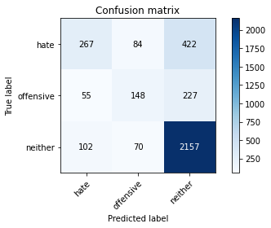

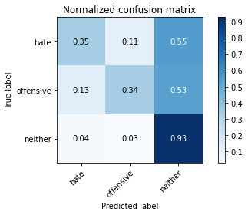

precision recall f1-score support

hate 0.63 0.35 0.45 773

offensive 0.49 0.34 0.40 430

neither 0.77 0.93 0.84 2329

accuracy 0.73 3532

macro avg 0.63 0.54 0.56 3532

weighted avg 0.70 0.73 0.70 3532

average eval_loss: 0.6710997734029415, accuracy: 0.7281993204983013

training 2 epoch...

85.44668650627136 seconds used......

2 training finished! average train loss: 0.9641004517021408

total clf loss: 125.15348887443542 total adv loss: 58.41786194592714

evaluating...

Confusion matrix, without normalization

[[ 333 52 388]

[ 84 130 216]

[ 135 45 2149]]

Normalized confusion matrix

[[0.43078913 0.06727038 0.50194049]

[0.19534884 0.30232558 0.50232558]

[0.05796479 0.0193216 0.92271361]]

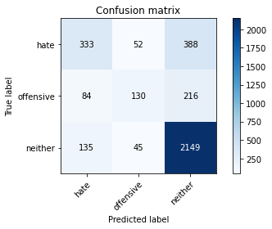

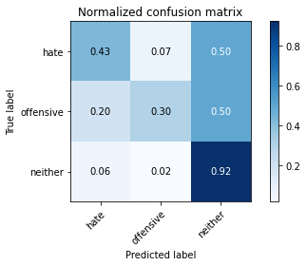

precision recall f1-score support

hate 0.60 0.43 0.50 773

offensive 0.57 0.30 0.40 430

neither 0.78 0.92 0.85 2329

accuracy 0.74 3532

macro avg 0.65 0.55 0.58 3532

weighted avg 0.72 0.74 0.72 3532

average eval_loss: 0.6745421855294772, accuracy: 0.739524348810872

training 3 epoch...

85.51071047782898 seconds used......

3 training finished! average train loss: 0.5825702263064594

total clf loss: 84.30039602145553 total adv loss: 30.962365495972335

evaluating...

Confusion matrix, without normalization

[[ 343 97 333]

[ 79 174 177]

[ 173 104 2052]]

Normalized confusion matrix

[[0.44372574 0.12548512 0.43078913]

[0.18372093 0.40465116 0.41162791]

[0.07428081 0.04465436 0.88106483]]

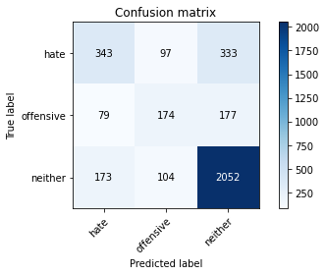

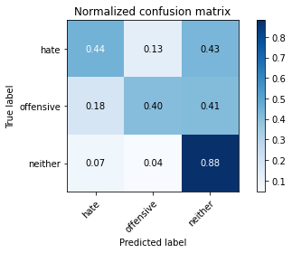

precision recall f1-score support

hate 0.58 0.44 0.50 773

offensive 0.46 0.40 0.43 430

neither 0.80 0.88 0.84 2329

accuracy 0.73 3532

macro avg 0.61 0.58 0.59 3532

weighted avg 0.71 0.73 0.72 3532

average eval_loss: 0.7437458171346093, accuracy: 0.7273499433748585

training 4 epoch...

85.41956949234009 seconds used......

4 training finished! average train loss: 0.32293724136582885

total clf loss: 51.79239288344979 total adv loss: 14.632427285250742

evaluating...

Confusion matrix, without normalization

[[ 297 67 409]

[ 54 142 234]

[ 94 55 2180]]

Normalized confusion matrix

[[0.38421734 0.08667529 0.52910737]

[0.1255814 0.33023256 0.54418605]

[0.04036067 0.02361529 0.93602404]]

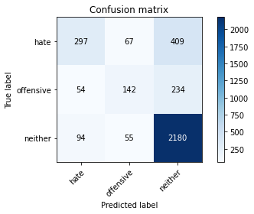

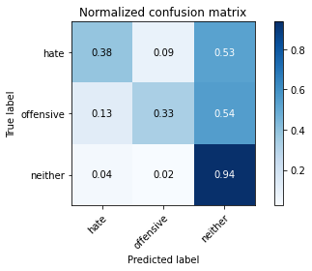

precision recall f1-score support

hate 0.67 0.38 0.49 773

offensive 0.54 0.33 0.41 430

neither 0.77 0.94 0.85 2329

accuracy 0.74 3532

macro avg 0.66 0.55 0.58 3532

weighted avg 0.72 0.74 0.71 3532

average eval_loss: 0.9085034174939334, accuracy: 0.7415062287655719

training 5 epoch...

85.43715167045593 seconds used......

5 training finished! average train loss: 0.18829099891106207

total clf loss: 34.44349327683449 total adv loss: 6.40877381098403

evaluating...

Confusion matrix, without normalization

[[ 264 90 419]

[ 60 152 218]

[ 103 81 2145]]

Normalized confusion matrix

[[0.34152652 0.1164295 0.54204398]

[0.13953488 0.35348837 0.50697674]

[0.04422499 0.03477888 0.92099614]]

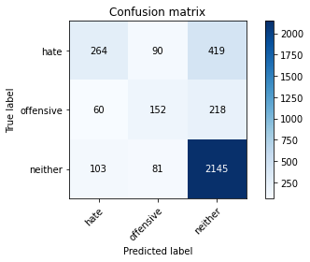

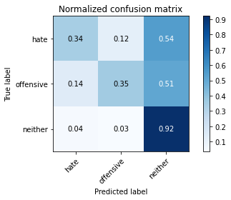

precision recall f1-score support

hate 0.62 0.34 0.44 773

offensive 0.47 0.35 0.40 430

neither 0.77 0.92 0.84 2329

accuracy 0.73 3532

macro avg 0.62 0.54 0.56 3532

weighted avg 0.70 0.73 0.70 3532

average eval_loss: 1.0608807312229933, accuracy: 0.7250849377123443

training 6 epoch...

85.47772979736328 seconds used......

6 training finished! average train loss: 0.10993561165340512

total clf loss: 21.128464544191957 total adv loss: 3.2326869701873875

evaluating...

Confusion matrix, without normalization

[[ 359 68 346]

[ 83 139 208]

[ 178 71 2080]]

Normalized confusion matrix

[[0.46442432 0.08796895 0.44760673]

[0.19302326 0.32325581 0.48372093]

[0.07642765 0.03048519 0.89308716]]

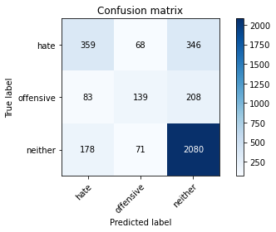

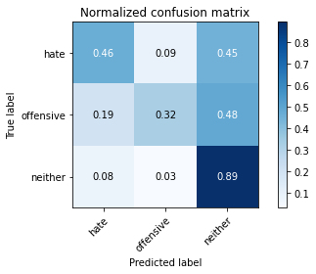

precision recall f1-score support

hate 0.58 0.46 0.52 773

offensive 0.50 0.32 0.39 430

neither 0.79 0.89 0.84 2329

accuracy 0.73 3532

macro avg 0.62 0.56 0.58 3532

weighted avg 0.71 0.73 0.71 3532

average eval_loss: 1.0704815955148579, accuracy: 0.7298980747451869

training 7 epoch...

85.47835993766785 seconds used......

7 training finished! average train loss: 0.05136762064347318

total clf loss: 11.369429514743388 total adv loss: 0.7619216326522746

evaluating...

Confusion matrix, without normalization

[[ 359 80 334]

[ 76 160 194]

[ 171 92 2066]]

Normalized confusion matrix

[[0.46442432 0.10349288 0.43208279]

[0.17674419 0.37209302 0.45116279]

[0.07342207 0.03950193 0.887076 ]]

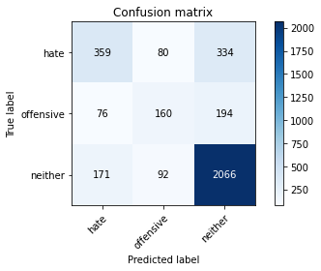

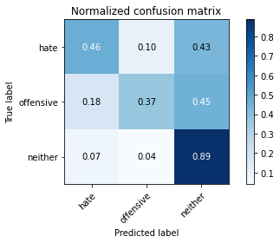

precision recall f1-score support

hate 0.59 0.46 0.52 773

offensive 0.48 0.37 0.42 430

neither 0.80 0.89 0.84 2329

accuracy 0.73 3532

macro avg 0.62 0.57 0.59 3532

weighted avg 0.71 0.73 0.72 3532

average eval_loss: 1.2198111289470208, accuracy: 0.7318799546998868

training 8 epoch...

85.42560267448425 seconds used......

8 training finished! average train loss: 0.06637659253676856

total clf loss: 8.85781408357434 total adv loss: 3.901355312942073

evaluating...

Confusion matrix, without normalization

[[ 276 110 387]

[ 55 165 210]

[ 112 102 2115]]

Normalized confusion matrix

[[0.35705045 0.14230272 0.50064683]

[0.12790698 0.38372093 0.48837209]

[0.04808931 0.04379562 0.90811507]]

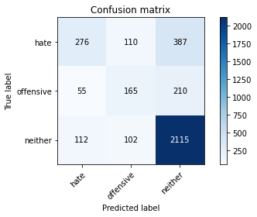

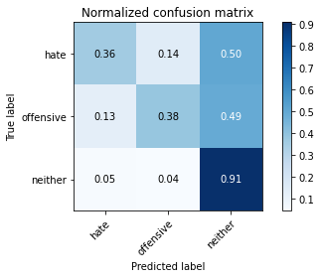

precision recall f1-score support

hate 0.62 0.36 0.45 773

offensive 0.44 0.38 0.41 430

neither 0.78 0.91 0.84 2329

accuracy 0.72 3532

macro avg 0.61 0.55 0.57 3532

weighted avg 0.70 0.72 0.70 3532

average eval_loss: 1.269570824621761, accuracy: 0.7236693091732729

training 9 epoch...

85.4567346572876 seconds used......

9 training finished! average train loss: 0.047282563201040476

total clf loss: 7.749905786826275 total adv loss: 2.059008780195086

evaluating...

Confusion matrix, without normalization

[[ 361 40 372]

[ 120 91 219]

[ 166 40 2123]]

Normalized confusion matrix

[[0.46701164 0.05174644 0.48124191]

[0.27906977 0.21162791 0.50930233]

[0.07127523 0.01717475 0.91155002]]

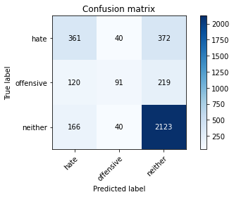

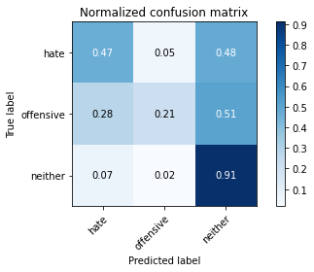

precision recall f1-score support

hate 0.56 0.47 0.51 773

offensive 0.53 0.21 0.30 430

neither 0.78 0.91 0.84 2329

accuracy 0.73 3532

macro avg 0.62 0.53 0.55 3532

weighted avg 0.70 0.73 0.70 3532

average eval_loss: 1.3904256310503362, accuracy: 0.7290486976217441

training 10 epoch...

85.38853287696838 seconds used......

10 training finished! average train loss: 0.04189846970129803

total clf loss: 5.753475794102997 total adv loss: 2.3815200086258983

evaluating...

Confusion matrix, without normalization

[[ 335 84 354]

[ 83 167 180]

[ 165 95 2069]]

Normalized confusion matrix

[[0.43337646 0.10866753 0.45795602]

[0.19302326 0.38837209 0.41860465]

[0.07084586 0.04079004 0.8883641 ]]

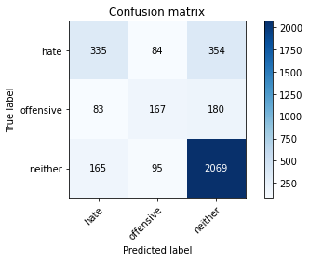

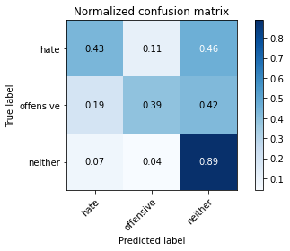

precision recall f1-score support

hate 0.57 0.43 0.49 773

offensive 0.48 0.39 0.43 430

neither 0.79 0.89 0.84 2329

accuracy 0.73 3532

macro avg 0.62 0.57 0.59 3532

weighted avg 0.71 0.73 0.71 3532

average eval_loss: 1.4429193011953332, accuracy: 0.727916194790487

2 run......

training 1 epoch...

85.45701932907104 seconds used......

1 training finished! average train loss: 1.4252671088830409

total clf loss: 184.86161890625954 total adv loss: 86.44021267071366

evaluating...

Confusion matrix, without normalization

[[ 163 33 577]

[ 32 72 326]

[ 32 17 2280]]

Normalized confusion matrix

[[0.21086675 0.04269082 0.74644243]

[0.0744186 0.16744186 0.75813953]

[0.0137398 0.00729927 0.97896093]]

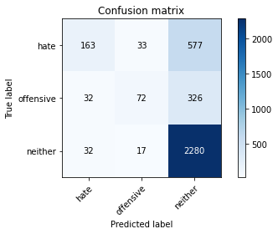

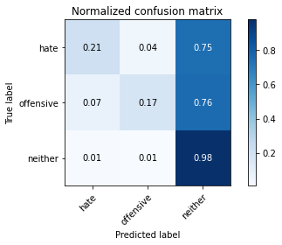

precision recall f1-score support

hate 0.72 0.21 0.33 773

offensive 0.59 0.17 0.26 430

neither 0.72 0.98 0.83 2329

accuracy 0.71 3532

macro avg 0.67 0.45 0.47 3532

weighted avg 0.70 0.71 0.65 3532

average eval_loss: 0.7453378595538058, accuracy: 0.7120611551528879

training 2 epoch...

85.42675733566284 seconds used......

2 training finished! average train loss: 0.975660632390425

total clf loss: 125.91203787922859 total adv loss: 59.489390570670366

evaluating...

Confusion matrix, without normalization

[[ 266 96 411]

[ 53 162 215]

[ 83 67 2179]]

Normalized confusion matrix

[[0.34411384 0.12419146 0.5316947 ]

[0.12325581 0.37674419 0.5 ]

[0.03563761 0.02876771 0.93559468]]

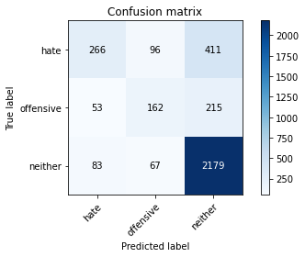

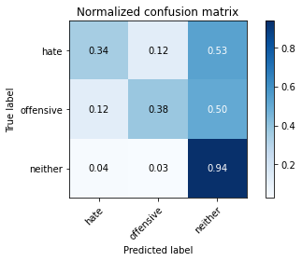

precision recall f1-score support

hate 0.66 0.34 0.45 773

offensive 0.50 0.38 0.43 430

neither 0.78 0.94 0.85 2329

accuracy 0.74 3532

macro avg 0.65 0.55 0.58 3532

weighted avg 0.72 0.74 0.71 3532

average eval_loss: 0.6968972398399633, accuracy: 0.7381087202718006

training 3 epoch...

85.43687343597412 seconds used......

3 training finished! average train loss: 0.5704011347783039

total clf loss: 82.88489201664925 total adv loss: 30.142896280740388

evaluating...

Confusion matrix, without normalization

[[ 301 57 415]

[ 62 118 250]

[ 99 43 2187]]

Normalized confusion matrix

[[0.38939198 0.07373868 0.53686934]

[0.14418605 0.2744186 0.58139535]

[0.04250751 0.01846286 0.93902963]]

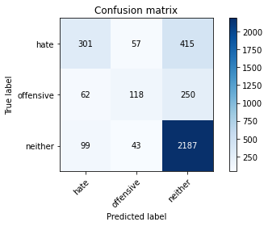

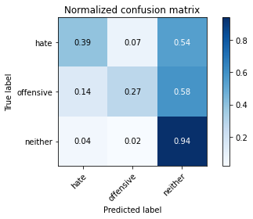

precision recall f1-score support

hate 0.65 0.39 0.49 773

offensive 0.54 0.27 0.36 430

neither 0.77 0.94 0.84 2329

accuracy 0.74 3532

macro avg 0.65 0.53 0.57 3532

weighted avg 0.71 0.74 0.71 3532

average eval_loss: 0.835815073911753, accuracy: 0.7378255945639864

training 4 epoch...

85.40253019332886 seconds used......

4 training finished! average train loss: 0.2745357882008847

total clf loss: 48.390627048909664 total adv loss: 10.258927845050493

evaluating...

Confusion matrix, without normalization

[[ 313 109 351]

[ 62 185 183]

[ 143 111 2075]]

Normalized confusion matrix

[[0.40491591 0.14100906 0.45407503]

[0.14418605 0.43023256 0.4255814 ]

[0.06139974 0.04765994 0.89094032]]

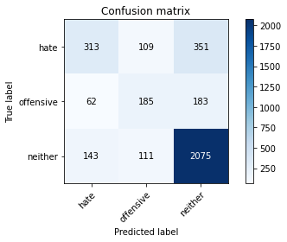

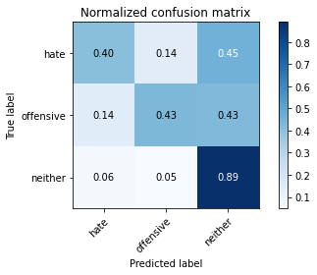

precision recall f1-score support

hate 0.60 0.40 0.48 773

offensive 0.46 0.43 0.44 430

neither 0.80 0.89 0.84 2329

accuracy 0.73 3532

macro avg 0.62 0.58 0.59 3532

weighted avg 0.71 0.73 0.71 3532

average eval_loss: 0.9289021804339468, accuracy: 0.7284824462061155

training 5 epoch...

85.34734869003296 seconds used......

5 training finished! average train loss: 0.18576946328449773

total clf loss: 31.94058912061155 total adv loss: 7.3437731725871345

evaluating...

Confusion matrix, without normalization

[[ 361 37 375]

[ 93 99 238]

[ 156 44 2129]]

Normalized confusion matrix

[[0.46701164 0.04786546 0.4851229 ]

[0.21627907 0.23023256 0.55348837]

[0.06698154 0.01889223 0.91412623]]

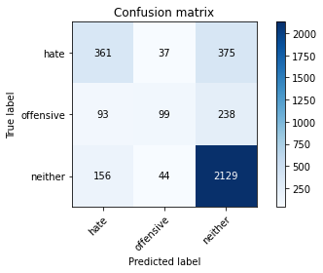

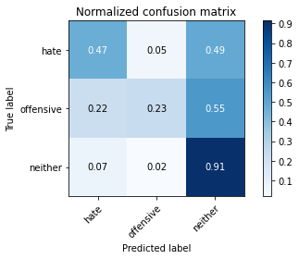

precision recall f1-score support

hate 0.59 0.47 0.52 773

offensive 0.55 0.23 0.32 430

neither 0.78 0.91 0.84 2329

accuracy 0.73 3532

macro avg 0.64 0.54 0.56 3532

weighted avg 0.71 0.73 0.71 3532

average eval_loss: 1.0765090971174887, accuracy: 0.7330124575311439

training 6 epoch...

85.35016989707947 seconds used......

6 training finished! average train loss: 0.127316550249642

total clf loss: 22.030800831038505 total adv loss: 4.962826677086241

evaluating...

Confusion matrix, without normalization

[[ 335 87 351]

[ 72 143 215]

[ 158 64 2107]]

Normalized confusion matrix

[[0.43337646 0.11254851 0.45407503]

[0.16744186 0.33255814 0.5 ]

[0.06784027 0.0274796 0.90468012]]

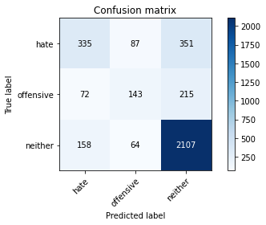

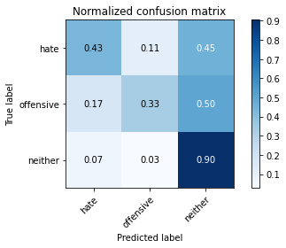

precision recall f1-score support

hate 0.59 0.43 0.50 773

offensive 0.49 0.33 0.40 430

neither 0.79 0.90 0.84 2329

accuracy 0.73 3532

macro avg 0.62 0.56 0.58 3532

weighted avg 0.71 0.73 0.71 3532

average eval_loss: 1.0927028043121942, accuracy: 0.7318799546998868

training 7 epoch...

85.37985563278198 seconds used......

7 training finished! average train loss: 0.10056939332345241

total clf loss: 14.545080211944878 total adv loss: 5.348918746318645

evaluating...

Confusion matrix, without normalization

[[ 305 102 366]

[ 65 165 200]

[ 126 96 2107]]

Normalized confusion matrix

[[0.39456662 0.13195343 0.47347995]

[0.15116279 0.38372093 0.46511628]

[0.05410047 0.04121941 0.90468012]]

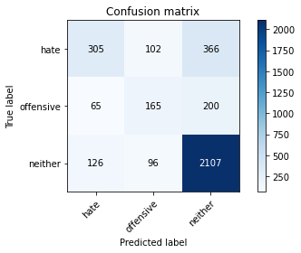

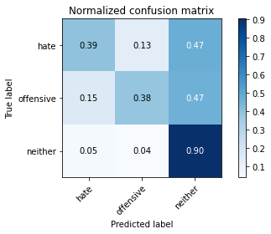

precision recall f1-score support

hate 0.61 0.39 0.48 773

offensive 0.45 0.38 0.42 430

neither 0.79 0.90 0.84 2329

accuracy 0.73 3532

macro avg 0.62 0.56 0.58 3532

weighted avg 0.71 0.73 0.71 3532

average eval_loss: 1.2281489811711392, accuracy: 0.7296149490373726

training 8 epoch...

85.41185307502747 seconds used......

8 training finished! average train loss: 0.04832745970280626

total clf loss: 8.172217510291375 total adv loss: 1.9789874281022435

evaluating...

Confusion matrix, without normalization

[[ 324 26 423]

[ 90 79 261]

[ 113 24 2192]]

Normalized confusion matrix

[[0.41914618 0.03363519 0.54721863]

[0.20930233 0.18372093 0.60697674]

[0.04851868 0.01030485 0.94117647]]

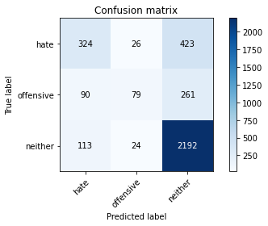

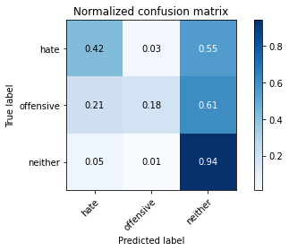

precision recall f1-score support

hate 0.61 0.42 0.50 773

offensive 0.61 0.18 0.28 430

neither 0.76 0.94 0.84 2329

accuracy 0.73 3532

macro avg 0.66 0.51 0.54 3532

weighted avg 0.71 0.73 0.70 3532

average eval_loss: 1.4836729801980788, accuracy: 0.7347112117780294

training 9 epoch...

85.34509253501892 seconds used......

9 training finished! average train loss: 0.033717377818851875

total clf loss: 5.389475346368272 total adv loss: 1.5367932636680024

evaluating...

Confusion matrix, without normalization

[[ 343 70 360]

[ 84 140 206]

[ 156 57 2116]]

Normalized confusion matrix

[[0.44372574 0.09055627 0.46571798]

[0.19534884 0.3255814 0.47906977]

[0.06698154 0.02447402 0.90854444]]

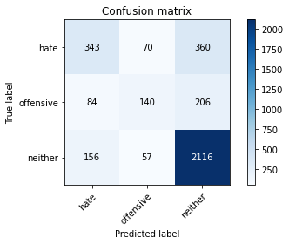

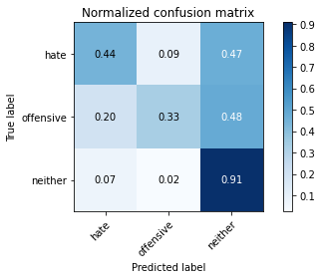

precision recall f1-score support

hate 0.59 0.44 0.51 773

offensive 0.52 0.33 0.40 430

neither 0.79 0.91 0.84 2329

accuracy 0.74 3532

macro avg 0.63 0.56 0.58 3532

weighted avg 0.71 0.74 0.72 3532

average eval_loss: 1.4489435096413403, accuracy: 0.7358437146092865

training 10 epoch...

85.36493301391602 seconds used......

10 training finished! average train loss: 0.013601086153096865

total clf loss: 3.2720528724312317 total adv loss: 0.0709098684560523

evaluating...

Confusion matrix, without normalization

[[ 338 83 352]

[ 82 155 193]

[ 156 71 2102]]

Normalized confusion matrix

[[0.43725744 0.10737387 0.45536869]

[0.19069767 0.36046512 0.44883721]

[0.06698154 0.03048519 0.90253328]]

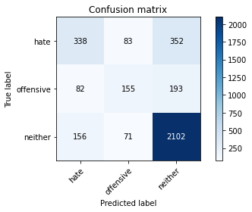

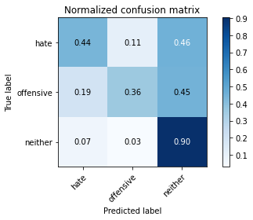

precision recall f1-score support

hate 0.59 0.44 0.50 773

offensive 0.50 0.36 0.42 430

neither 0.79 0.90 0.84 2329

accuracy 0.73 3532

macro avg 0.63 0.57 0.59 3532

weighted avg 0.71 0.73 0.72 3532

average eval_loss: 1.5808532679990186, accuracy: 0.7347112117780294

3 run......

training 1 epoch...

85.30165505409241 seconds used......

1 training finished! average train loss: 1.432841559805243

total clf loss: 186.41266655921936 total adv loss: 86.6152828335762

evaluating...

Confusion matrix, without normalization

[[ 194 40 539]

[ 46 84 300]

[ 41 15 2273]]

Normalized confusion matrix

[[0.25097025 0.05174644 0.69728331]

[0.10697674 0.19534884 0.69767442]

[0.01760412 0.00644053 0.97595535]]

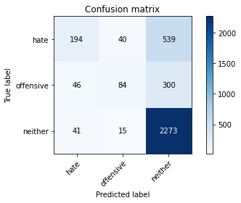

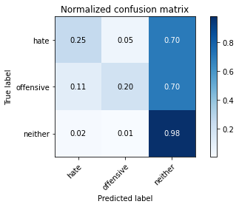

precision recall f1-score support

hate 0.69 0.25 0.37 773

offensive 0.60 0.20 0.30 430

neither 0.73 0.98 0.84 2329

accuracy 0.72 3532

macro avg 0.68 0.47 0.50 3532

weighted avg 0.71 0.72 0.67 3532

average eval_loss: 0.7156198183021977, accuracy: 0.7222536806342016

training 2 epoch...

85.43821263313293 seconds used......

2 training finished! average train loss: 0.988908611801991

total clf loss: 128.21108324825764 total adv loss: 60.0024890601635

evaluating...

Confusion matrix, without normalization

[[ 204 84 485]

[ 36 152 242]

[ 41 50 2238]]

Normalized confusion matrix

[[0.26390686 0.10866753 0.62742561]

[0.08372093 0.35348837 0.5627907 ]

[0.01760412 0.02146844 0.96092744]]

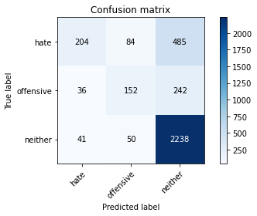

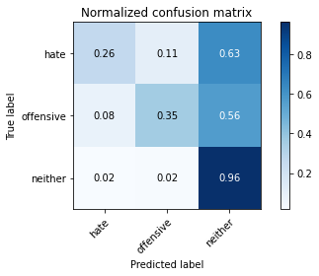

precision recall f1-score support

hate 0.73 0.26 0.39 773

offensive 0.53 0.35 0.42 430

neither 0.75 0.96 0.85 2329

accuracy 0.73 3532

macro avg 0.67 0.53 0.55 3532

weighted avg 0.72 0.73 0.69 3532

average eval_loss: 0.7318562726348133, accuracy: 0.7344280860702151

training 3 epoch...

85.3262825012207 seconds used......

3 training finished! average train loss: 0.5887447894806881

total clf loss: 84.31112260371447 total adv loss: 31.731909793801606

evaluating...

Confusion matrix, without normalization

[[ 311 33 429]

[ 102 94 234]

[ 117 30 2182]]

Normalized confusion matrix

[[0.40232859 0.04269082 0.5549806 ]

[0.2372093 0.21860465 0.54418605]

[0.05023615 0.01288106 0.93688278]]

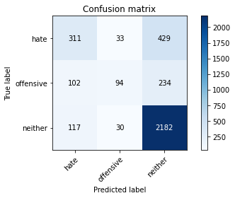

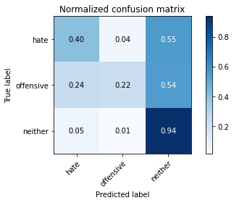

precision recall f1-score support

hate 0.59 0.40 0.48 773

offensive 0.60 0.22 0.32 430

neither 0.77 0.94 0.84 2329

accuracy 0.73 3532

macro avg 0.65 0.52 0.55 3532

weighted avg 0.71 0.73 0.70 3532

average eval_loss: 0.8221896746232684, accuracy: 0.7324462061155153

training 4 epoch...

85.3471908569336 seconds used......

4 training finished! average train loss: 0.297858935903268

total clf loss: 50.64699372649193 total adv loss: 12.057799563801382

evaluating...

Confusion matrix, without normalization

[[ 325 85 363]

[ 85 153 192]

[ 144 79 2106]]

Normalized confusion matrix

[[0.42043984 0.10996119 0.46959897]

[0.19767442 0.35581395 0.44651163]

[0.06182911 0.03392014 0.90425075]]

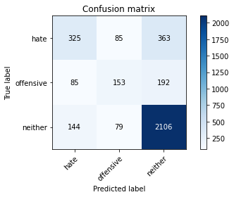

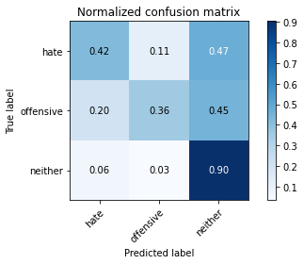

precision recall f1-score support

hate 0.59 0.42 0.49 773

offensive 0.48 0.36 0.41 430

neither 0.79 0.90 0.84 2329

accuracy 0.73 3532

macro avg 0.62 0.56 0.58 3532

weighted avg 0.71 0.73 0.71 3532

average eval_loss: 0.900326594457788, accuracy: 0.7315968289920725

training 5 epoch...

85.2647933959961 seconds used......

5 training finished! average train loss: 0.1766439487348752

total clf loss: 33.77943361736834 total adv loss: 5.2790987502066855

evaluating...

Confusion matrix, without normalization

[[ 338 110 325]

[ 76 186 168]

[ 186 114 2029]]

Normalized confusion matrix

[[0.43725744 0.14230272 0.42043984]

[0.17674419 0.43255814 0.39069767]

[0.0798626 0.04894805 0.87118935]]

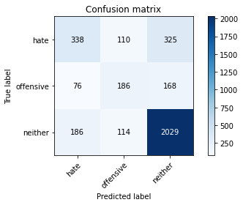

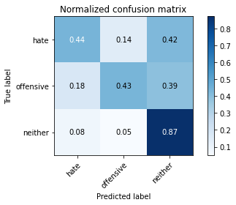

precision recall f1-score support

hate 0.56 0.44 0.49 773

offensive 0.45 0.43 0.44 430

neither 0.80 0.87 0.84 2329

accuracy 0.72 3532

macro avg 0.61 0.58 0.59 3532

weighted avg 0.71 0.72 0.71 3532

average eval_loss: 0.9583887350929658, accuracy: 0.7228199320498301

training 6 epoch...

85.32792472839355 seconds used......

6 training finished! average train loss: 0.1238737277894381

total clf loss: 22.4703845763579 total adv loss: 4.310960523378526

evaluating...

Confusion matrix, without normalization

[[ 341 88 344]

[ 87 158 185]

[ 152 85 2092]]

Normalized confusion matrix

[[0.44113842 0.11384217 0.4450194 ]

[0.20232558 0.36744186 0.43023256]

[0.06526406 0.03649635 0.89823959]]

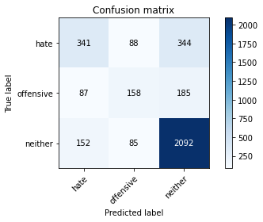

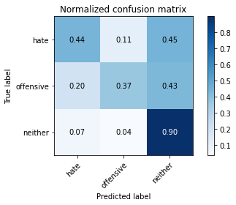

precision recall f1-score support

hate 0.59 0.44 0.50 773

offensive 0.48 0.37 0.42 430

neither 0.80 0.90 0.85 2329

accuracy 0.73 3532

macro avg 0.62 0.57 0.59 3532

weighted avg 0.71 0.73 0.72 3532

average eval_loss: 1.0538188013653298, accuracy: 0.7335787089467724

training 7 epoch...

85.35832357406616 seconds used......

7 training finished! average train loss: 0.08639164829619259

total clf loss: 14.526426477357745 total adv loss: 3.578938637252577

evaluating...

Confusion matrix, without normalization

[[ 318 65 390]

[ 75 140 215]

[ 129 55 2145]]

Normalized confusion matrix

[[0.41138422 0.08408797 0.50452781]

[0.1744186 0.3255814 0.5 ]

[0.05538858 0.02361529 0.92099614]]

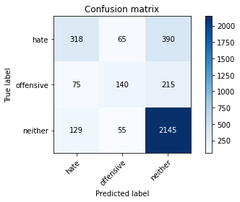

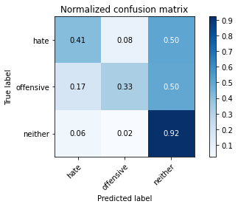

precision recall f1-score support

hate 0.61 0.41 0.49 773

offensive 0.54 0.33 0.41 430

neither 0.78 0.92 0.84 2329

accuracy 0.74 3532

macro avg 0.64 0.55 0.58 3532

weighted avg 0.71 0.74 0.71 3532

average eval_loss: 1.1769262971514363, accuracy: 0.7369762174405436

training 8 epoch...

85.39074873924255 seconds used......

8 training finished! average train loss: 0.04646953475379582

total clf loss: 8.390265427529812 total adv loss: 1.636793882441225

evaluating...

Confusion matrix, without normalization

[[ 341 72 360]

[ 94 153 183]

[ 174 60 2095]]

Normalized confusion matrix

[[0.44113842 0.0931436 0.46571798]

[0.21860465 0.35581395 0.4255814 ]

[0.07471018 0.02576213 0.89952769]]

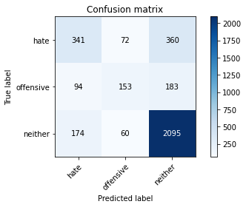

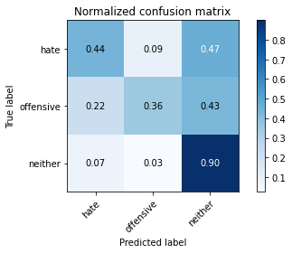

precision recall f1-score support

hate 0.56 0.44 0.49 773

offensive 0.54 0.36 0.43 430

neither 0.79 0.90 0.84 2329

accuracy 0.73 3532

macro avg 0.63 0.57 0.59 3532

weighted avg 0.71 0.73 0.72 3532

average eval_loss: 1.2627520640354373, accuracy: 0.7330124575311439

training 9 epoch...

85.35875463485718 seconds used......

9 training finished! average train loss: 0.04869145423543094

total clf loss: 7.671553321299143 total adv loss: 2.275000868503696

evaluating...

Confusion matrix, without normalization

[[ 333 55 385]

[ 84 144 202]

[ 143 59 2127]]

Normalized confusion matrix

[[0.43078913 0.07115136 0.49805951]

[0.19534884 0.33488372 0.46976744]

[0.06139974 0.02533276 0.9132675 ]]

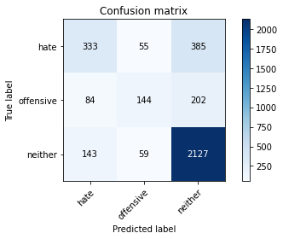

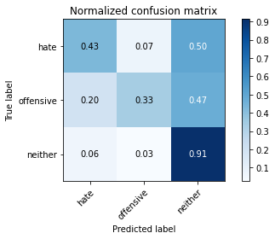

precision recall f1-score support

hate 0.59 0.43 0.50 773

offensive 0.56 0.33 0.42 430

neither 0.78 0.91 0.84 2329

accuracy 0.74 3532

macro avg 0.65 0.56 0.59 3532

weighted avg 0.71 0.74 0.72 3532

average eval_loss: 1.4228439109641953, accuracy: 0.7372593431483578

training 10 epoch...

85.27482724189758 seconds used......

10 training finished! average train loss: 0.037202055454003694

total clf loss: 5.578338919498492 total adv loss: 1.8796885296072503

evaluating...

Confusion matrix, without normalization

[[ 327 104 342]

[ 61 197 172]

[ 166 113 2050]]

Normalized confusion matrix

[[0.42302717 0.13454075 0.44243208]

[0.14186047 0.45813953 0.4 ]

[0.07127523 0.04851868 0.8802061 ]]

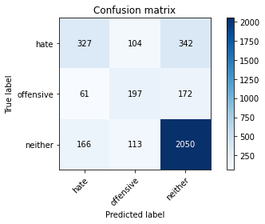

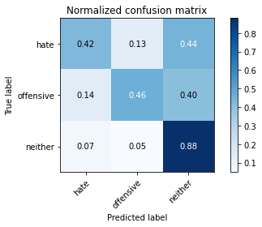

precision recall f1-score support

hate 0.59 0.42 0.49 773

offensive 0.48 0.46 0.47 430

neither 0.80 0.88 0.84 2329

accuracy 0.73 3532

macro avg 0.62 0.59 0.60 3532

weighted avg 0.71 0.73 0.72 3532

average eval_loss: 1.3948440038214969, accuracy: 0.7287655719139298

4 run......

training 1 epoch...

85.25589299201965 seconds used......

1 training finished! average train loss: 1.4401649966895342

total clf loss: 188.837906524539 total adv loss: 86.32175323367119

evaluating...

Confusion matrix, without normalization

[[ 252 62 459]

[ 70 134 226]

[ 84 65 2180]]

Normalized confusion matrix

[[0.32600259 0.08020699 0.59379043]

[0.1627907 0.31162791 0.5255814 ]

[0.03606698 0.02790897 0.93602404]]

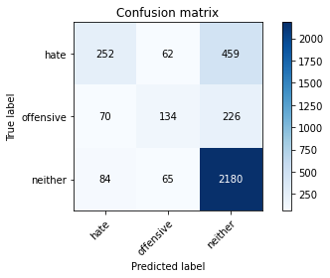

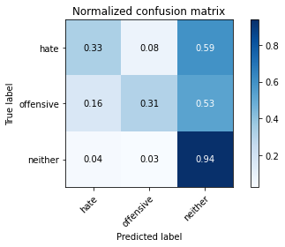

precision recall f1-score support

hate 0.62 0.33 0.43 773

offensive 0.51 0.31 0.39 430

neither 0.76 0.94 0.84 2329

accuracy 0.73 3532

macro avg 0.63 0.52 0.55 3532

weighted avg 0.70 0.73 0.69 3532

average eval_loss: 0.6799830967760355, accuracy: 0.7265005662514157

training 2 epoch...

85.23457717895508 seconds used......

2 training finished! average train loss: 0.9696810304881092

total clf loss: 126.08530168235302 total adv loss: 58.652318314649165

evaluating...

Confusion matrix, without normalization

[[ 322 80 371]

[ 86 158 186]

[ 133 85 2111]]

Normalized confusion matrix

[[0.41655886 0.10349288 0.47994825]

[0.2 0.36744186 0.43255814]

[0.05710605 0.03649635 0.9063976 ]]

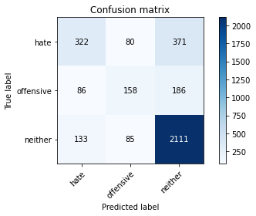

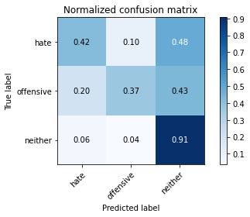

precision recall f1-score support

hate 0.60 0.42 0.49 773

offensive 0.49 0.37 0.42 430

neither 0.79 0.91 0.84 2329

accuracy 0.73 3532

macro avg 0.63 0.56 0.58 3532

weighted avg 0.71 0.73 0.72 3532

average eval_loss: 0.66697286869173, accuracy: 0.7335787089467724

training 3 epoch...

85.2715847492218 seconds used......

3 training finished! average train loss: 0.610336674102749

total clf loss: 86.89434018731117 total adv loss: 33.15008242847398

evaluating...

Confusion matrix, without normalization

[[ 231 49 493]

[ 49 104 277]

[ 49 30 2250]]

Normalized confusion matrix

[[0.29883571 0.06338939 0.6377749 ]

[0.11395349 0.24186047 0.64418605]

[0.02103907 0.01288106 0.96607986]]

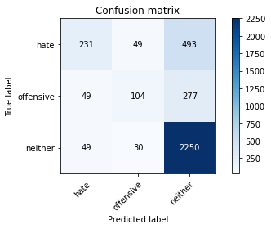

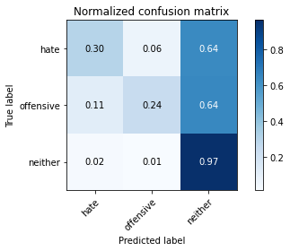

precision recall f1-score support

hate 0.70 0.30 0.42 773

offensive 0.57 0.24 0.34 430

neither 0.75 0.97 0.84 2329

accuracy 0.73 3532

macro avg 0.67 0.50 0.53 3532

weighted avg 0.71 0.73 0.69 3532

average eval_loss: 0.8286490407535585, accuracy: 0.7318799546998868

training 4 epoch...

85.35781145095825 seconds used......

4 training finished! average train loss: 0.28856647203850794

total clf loss: 49.57632546685636 total adv loss: 11.42692939848348

evaluating...

Confusion matrix, without normalization

[[ 326 92 355]

[ 74 147 209]

[ 158 84 2087]]

Normalized confusion matrix

[[0.42173351 0.11901682 0.45924968]

[0.17209302 0.34186047 0.48604651]

[0.06784027 0.03606698 0.89609274]]

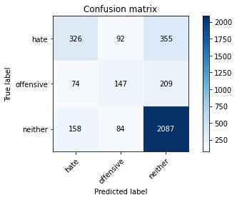

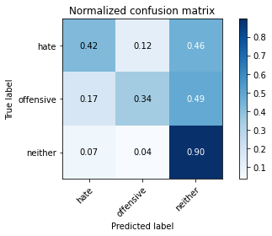

precision recall f1-score support

hate 0.58 0.42 0.49 773

offensive 0.46 0.34 0.39 430

neither 0.79 0.90 0.84 2329

accuracy 0.72 3532

macro avg 0.61 0.55 0.57 3532

weighted avg 0.70 0.72 0.71 3532

average eval_loss: 0.9152479479036763, accuracy: 0.72480181200453

training 5 epoch...

85.3423182964325 seconds used......

5 training finished! average train loss: 0.16139301140440176

total clf loss: 29.8664332870394 total adv loss: 5.32160625304823

evaluating...

Confusion matrix, without normalization

[[ 272 118 383]

[ 61 174 195]

[ 110 91 2128]]

Normalized confusion matrix

[[0.35187581 0.15265201 0.49547219]

[0.14186047 0.40465116 0.45348837]

[0.04723057 0.03907256 0.91369687]]

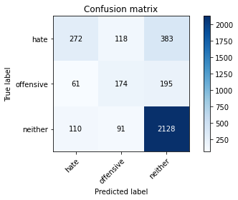

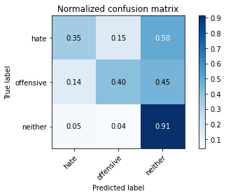

precision recall f1-score support

hate 0.61 0.35 0.45 773

offensive 0.45 0.40 0.43 430

neither 0.79 0.91 0.85 2329

accuracy 0.73 3532

macro avg 0.62 0.56 0.57 3532

weighted avg 0.71 0.73 0.71 3532

average eval_loss: 1.0700011111922183, accuracy: 0.7287655719139298

training 6 epoch...

85.29205703735352 seconds used......

6 training finished! average train loss: 0.10428097381059867

total clf loss: 19.686255609150976 total adv loss: 3.2441343871678328

evaluating...

Confusion matrix, without normalization

[[ 397 65 311]

[ 114 134 182]

[ 213 69 2047]]

Normalized confusion matrix

[[0.51358344 0.08408797 0.40232859]

[0.26511628 0.31162791 0.42325581]

[0.09145556 0.02962645 0.87891799]]

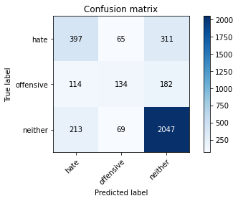

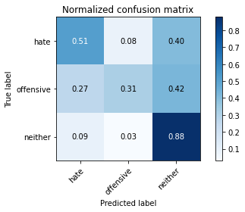

precision recall f1-score support

hate 0.55 0.51 0.53 773

offensive 0.50 0.31 0.38 430

neither 0.81 0.88 0.84 2329

accuracy 0.73 3532

macro avg 0.62 0.57 0.59 3532

weighted avg 0.71 0.73 0.72 3532

average eval_loss: 1.0755698643835252, accuracy: 0.7298980747451869

training 7 epoch...

85.28613257408142 seconds used......

7 training finished! average train loss: 0.06630535413551912

total clf loss: 11.38608091371134 total adv loss: 2.6282814547967064

evaluating...

Confusion matrix, without normalization

[[ 327 70 376]

[ 89 136 205]

[ 139 69 2121]]

Normalized confusion matrix

[[0.42302717 0.09055627 0.48641656]

[0.20697674 0.31627907 0.47674419]

[0.05968227 0.02962645 0.91069128]]

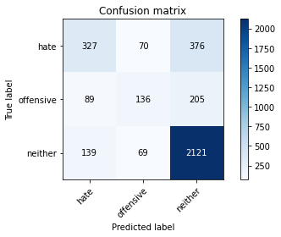

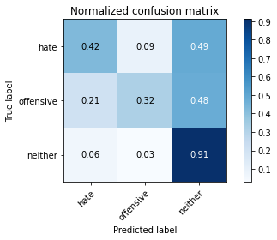

precision recall f1-score support

hate 0.59 0.42 0.49 773

offensive 0.49 0.32 0.39 430

neither 0.78 0.91 0.84 2329

accuracy 0.73 3532

macro avg 0.62 0.55 0.57 3532

weighted avg 0.71 0.73 0.71 3532

average eval_loss: 1.2436601606297628, accuracy: 0.7315968289920725

training 8 epoch...

85.35933661460876 seconds used......

8 training finished! average train loss: 0.05955498027188547

total clf loss: 9.06012667878531 total adv loss: 2.9440866919394466

evaluating...

Confusion matrix, without normalization

[[ 282 164 327]

[ 51 203 176]

[ 137 151 2041]]

Normalized confusion matrix

[[0.36481242 0.21216041 0.42302717]

[0.11860465 0.47209302 0.40930233]

[0.05882353 0.06483469 0.87634178]]

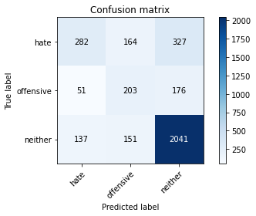

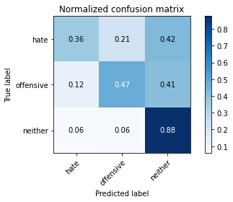

precision recall f1-score support

hate 0.60 0.36 0.45 773

offensive 0.39 0.47 0.43 430

neither 0.80 0.88 0.84 2329

accuracy 0.72 3532

macro avg 0.60 0.57 0.57 3532

weighted avg 0.71 0.72 0.70 3532

average eval_loss: 1.29173881926779, accuracy: 0.7151755379388448

training 9 epoch...

85.30105066299438 seconds used......

9 training finished! average train loss: 0.05732747900116061

total clf loss: 7.422747247852385 total adv loss: 3.4832249594282416

evaluating...

Confusion matrix, without normalization

[[ 353 85 335]

[ 73 160 197]

[ 173 99 2057]]

Normalized confusion matrix

[[0.45666235 0.10996119 0.43337646]

[0.16976744 0.37209302 0.45813953]

[0.07428081 0.04250751 0.88321168]]

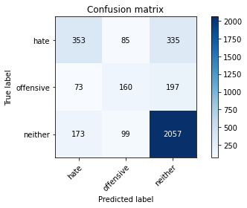

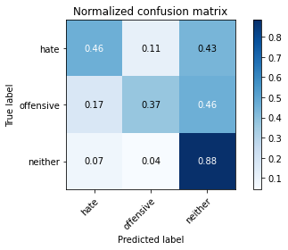

precision recall f1-score support

hate 0.59 0.46 0.51 773

offensive 0.47 0.37 0.41 430

neither 0.79 0.88 0.84 2329

accuracy 0.73 3532

macro avg 0.62 0.57 0.59 3532

weighted avg 0.71 0.73 0.71 3532

average eval_loss: 1.3351363700914518, accuracy: 0.7276330690826727

training 10 epoch...

85.28315258026123 seconds used......

10 training finished! average train loss: 0.03500438395069459

total clf loss: 4.67282056849217 total adv loss: 2.0566399027096196

evaluating...

Confusion matrix, without normalization

[[ 322 113 338]

[ 71 178 181]

[ 147 118 2064]]

Normalized confusion matrix

[[0.41655886 0.1461837 0.43725744]

[0.16511628 0.41395349 0.42093023]

[0.06311722 0.05066552 0.88621726]]

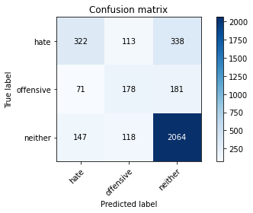

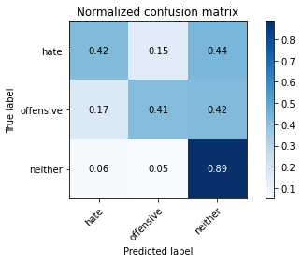

precision recall f1-score support

hate 0.60 0.42 0.49 773

offensive 0.44 0.41 0.42 430

neither 0.80 0.89 0.84 2329

accuracy 0.73 3532

macro avg 0.61 0.57 0.59 3532

weighted avg 0.71 0.73 0.71 3532

average eval_loss: 1.4014294959899396, accuracy: 0.7259343148357871

5 run......

training 1 epoch...

85.25793075561523 seconds used......

1 training finished! average train loss: 1.433619850897694

total clf loss: 185.85040366649628 total adv loss: 86.99408943206072

evaluating...

Confusion matrix, without normalization

[[ 370 21 382]

[ 123 76 231]

[ 178 28 2123]]

Normalized confusion matrix

[[0.47865459 0.02716688 0.49417853]

[0.28604651 0.17674419 0.5372093 ]

[0.07642765 0.01202233 0.91155002]]

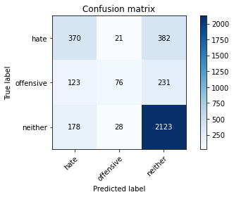

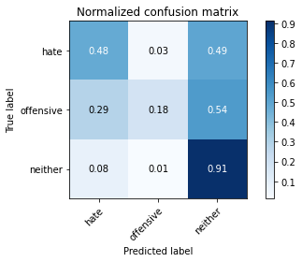

precision recall f1-score support

hate 0.55 0.48 0.51 773

offensive 0.61 0.18 0.27 430

neither 0.78 0.91 0.84 2329

accuracy 0.73 3532

macro avg 0.65 0.52 0.54 3532

weighted avg 0.71 0.73 0.70 3532

average eval_loss: 0.6808498527033854, accuracy: 0.7273499433748585

training 2 epoch...

85.23754453659058 seconds used......

2 training finished! average train loss: 0.9917202335429857

total clf loss: 128.05338191986084 total adv loss: 60.434198800008744

evaluating...

Confusion matrix, without normalization

[[ 296 105 372]

[ 51 176 203]

[ 109 86 2134]]

Normalized confusion matrix

[[0.38292367 0.13583441 0.48124191]

[0.11860465 0.40930233 0.47209302]

[0.0468012 0.03692572 0.91627308]]

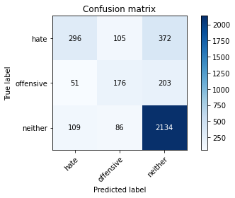

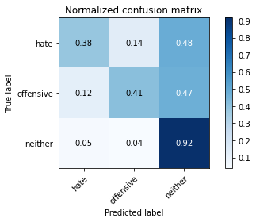

precision recall f1-score support

hate 0.65 0.38 0.48 773

offensive 0.48 0.41 0.44 430

neither 0.79 0.92 0.85 2329

accuracy 0.74 3532

macro avg 0.64 0.57 0.59 3532

weighted avg 0.72 0.74 0.72 3532

average eval_loss: 0.6828554575726137, accuracy: 0.7378255945639864

training 3 epoch...

85.23811912536621 seconds used......

3 training finished! average train loss: 0.604871273218873

total clf loss: 85.02511993795633 total adv loss: 33.398785065393895

evaluating...

Confusion matrix, without normalization

[[ 346 58 369]

[ 91 132 207]

[ 148 53 2128]]

Normalized confusion matrix

[[0.44760673 0.07503234 0.47736093]

[0.21162791 0.30697674 0.48139535]

[0.06354659 0.02275655 0.91369687]]

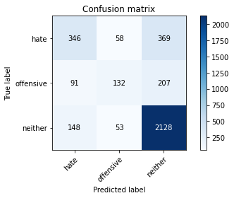

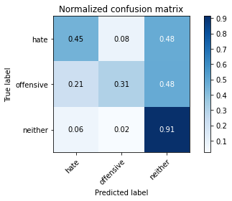

precision recall f1-score support

hate 0.59 0.45 0.51 773

offensive 0.54 0.31 0.39 430

neither 0.79 0.91 0.85 2329

accuracy 0.74 3532

macro avg 0.64 0.56 0.58 3532

weighted avg 0.71 0.74 0.72 3532

average eval_loss: 0.7651894714704341, accuracy: 0.7378255945639864

training 4 epoch...

85.3207654953003 seconds used......

4 training finished! average train loss: 0.32435668947034146

total clf loss: 53.02380017004907 total adv loss: 14.19486449379474

evaluating...

Confusion matrix, without normalization

[[ 296 70 407]

[ 68 140 222]

[ 111 62 2156]]

Normalized confusion matrix

[[0.38292367 0.09055627 0.52652005]

[0.15813953 0.3255814 0.51627907]

[0.04765994 0.02662087 0.92571919]]

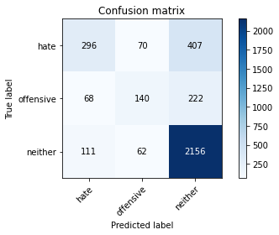

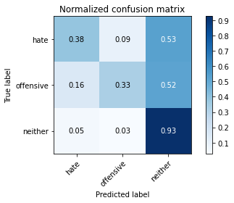

precision recall f1-score support

hate 0.62 0.38 0.47 773

offensive 0.51 0.33 0.40 430

neither 0.77 0.93 0.84 2329

accuracy 0.73 3532

macro avg 0.64 0.54 0.57 3532

weighted avg 0.71 0.73 0.71 3532

average eval_loss: 0.8884323465790452, accuracy: 0.7338618346545867

training 5 epoch...

85.22829174995422 seconds used......

5 training finished! average train loss: 0.18457611934448856

total clf loss: 32.36127092130482 total adv loss: 6.983667625883072

evaluating...

Confusion matrix, without normalization

[[ 380 120 273]

[ 69 213 148]

[ 231 148 1950]]

Normalized confusion matrix

[[0.4915912 0.15523933 0.35316947]

[0.16046512 0.49534884 0.34418605]

[0.0991842 0.06354659 0.83726921]]

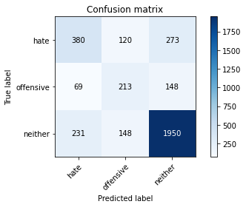

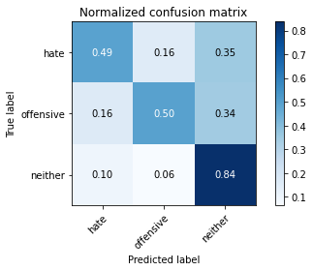

precision recall f1-score support

hate 0.56 0.49 0.52 773

offensive 0.44 0.50 0.47 430

neither 0.82 0.84 0.83 2329

accuracy 0.72 3532

macro avg 0.61 0.61 0.61 3532

weighted avg 0.72 0.72 0.72 3532

average eval_loss: 0.9522593345514125, accuracy: 0.7199886749716874

training 6 epoch...

85.27645468711853 seconds used......

6 training finished! average train loss: 0.11525629425562355

total clf loss: 21.31678889505565 total adv loss: 3.806270454811056

evaluating...

Confusion matrix, without normalization

[[ 219 108 446]

[ 34 177 219]

[ 64 77 2188]]

Normalized confusion matrix

[[0.28331177 0.13971539 0.57697283]

[0.07906977 0.41162791 0.50930233]

[0.0274796 0.0330614 0.939459 ]]

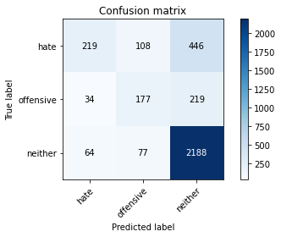

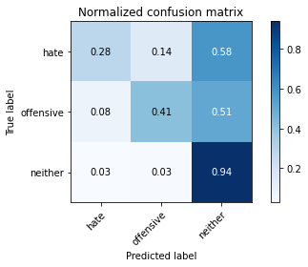

precision recall f1-score support

hate 0.69 0.28 0.40 773

offensive 0.49 0.41 0.45 430

neither 0.77 0.94 0.84 2329

accuracy 0.73 3532

macro avg 0.65 0.54 0.56 3532

weighted avg 0.72 0.73 0.70 3532

average eval_loss: 1.239624452792992, accuracy: 0.7315968289920725

training 7 epoch...

85.32871890068054 seconds used......

7 training finished! average train loss: 0.08664124438156971

total clf loss: 14.340248642489314 total adv loss: 3.7033518219859616

evaluating...

Confusion matrix, without normalization

[[ 416 60 297]

[ 120 144 166]

[ 262 81 1986]]

Normalized confusion matrix

[[0.538163 0.07761966 0.38421734]

[0.27906977 0.33488372 0.38604651]

[0.11249463 0.03477888 0.85272649]]

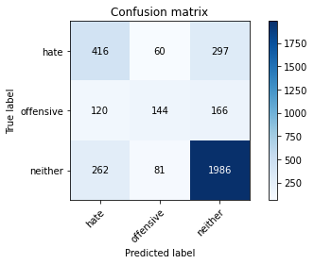

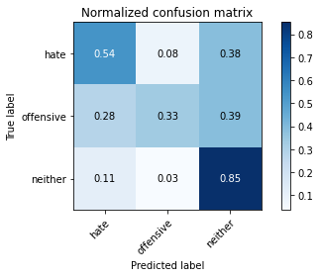

precision recall f1-score support

hate 0.52 0.54 0.53 773

offensive 0.51 0.33 0.40 430

neither 0.81 0.85 0.83 2329

accuracy 0.72 3532

macro avg 0.61 0.58 0.59 3532

weighted avg 0.71 0.72 0.71 3532

average eval_loss: 1.1837657677420115, accuracy: 0.7208380520951302

training 8 epoch...

85.35701847076416 seconds used......

8 training finished! average train loss: 0.05030186765686241

total clf loss: 9.31385354953818 total adv loss: 1.6559576040181128

evaluating...

Confusion matrix, without normalization

[[ 338 88 347]

[ 82 173 175]

[ 184 104 2041]]

Normalized confusion matrix

[[0.43725744 0.11384217 0.44890039]

[0.19069767 0.40232558 0.40697674]

[0.07900386 0.04465436 0.87634178]]

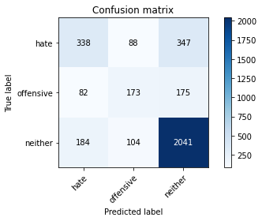

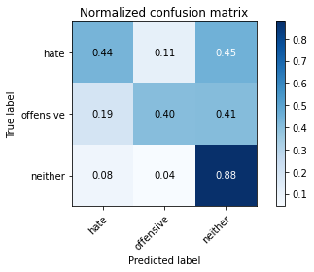

precision recall f1-score support

hate 0.56 0.44 0.49 773

offensive 0.47 0.40 0.44 430

neither 0.80 0.88 0.83 2329

accuracy 0.72 3532

macro avg 0.61 0.57 0.59 3532

weighted avg 0.71 0.72 0.71 3532

average eval_loss: 1.2975089074359776, accuracy: 0.7225368063420159

training 9 epoch...

85.28274655342102 seconds used......

9 training finished! average train loss: 0.050255024767169115

total clf loss: 6.502902312437072 total adv loss: 3.0555544850598153

evaluating...

Confusion matrix, without normalization

[[ 351 63 359]

[ 77 134 219]

[ 174 61 2094]]

Normalized confusion matrix

[[0.45407503 0.08150065 0.46442432]

[0.17906977 0.31162791 0.50930233]

[0.07471018 0.0261915 0.89909833]]

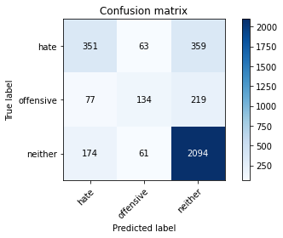

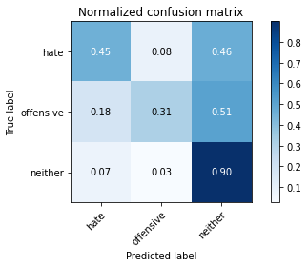

precision recall f1-score support

hate 0.58 0.45 0.51 773

offensive 0.52 0.31 0.39 430

neither 0.78 0.90 0.84 2329

accuracy 0.73 3532

macro avg 0.63 0.55 0.58 3532

weighted avg 0.71 0.73 0.71 3532

average eval_loss: 1.3350438457087608, accuracy: 0.7301812004530012

training 10 epoch...

85.29752349853516 seconds used......

10 training finished! average train loss: 0.03114090589004053

total clf loss: 4.050715793593554 total adv loss: 1.8828257674515783

evaluating...

Confusion matrix, without normalization

[[ 306 78 389]

[ 70 146 214]

[ 144 70 2115]]

Normalized confusion matrix

[[0.39586028 0.10090556 0.50323415]

[0.1627907 0.33953488 0.49767442]

[0.06182911 0.03005582 0.90811507]]

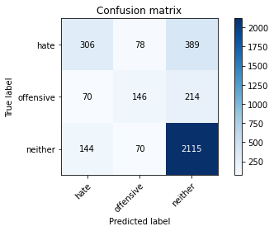

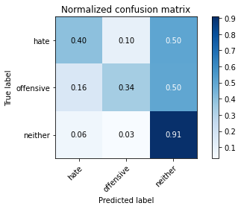

precision recall f1-score support

hate 0.59 0.40 0.47 773

offensive 0.50 0.34 0.40 430

neither 0.78 0.91 0.84 2329

accuracy 0.73 3532

macro avg 0.62 0.55 0.57 3532

weighted avg 0.70 0.73 0.71 3532

average eval_loss: 1.5339512890678342, accuracy: 0.7267836919592299